Last Revised: September 2, 2014

Instructions to Authors: Submission Guidelines and Uploading an Article

The Western Journal of Emergency Medicine: Integrating Emergency Care with Population Health (WestJEM) solicits contributions for publication through www.westjem.org including, original research, review articles, editorial opinions, letters to the editor, case reports, visual diagnosis, and other topics.

Guidelines:
Category | Word Count Limit | Figure, Tables and Images Limit (combined) | Abstract Limit
Original Research | 4000 | 7 | 350
Brief Research Report | 1500 | 2 | 350
Educational advances | 3000 | 4 | 350
Review | 4000 | 5 | 350
Case Report | 1750 | 2 | 100
Editorials (Invited) | 1500 | None | None
Images | 300 | 1 | None
Letters to the editor | 500 | None | None

WestJEM adheres to the Uniform Requirements for Manuscripts Submitted to Biomedical Journals: Writing and Editing for Biomedical Publication. By the Western Journal of Emergency Medicine article submission agreement, all authors are required to disclose all affiliations, funding sources, and financial or management relationships that could be perceived as potential sources of bias. All editors, editorial staff and editorial board members are also required to disclose any potential conflicts of interest.

Submission Guidelines:

1. Peer Review Blinding
• Remove any mention to author(s) and the site of work from the body of the text as well as
in the properties of the document. These should only appear on the cover letter (uploaded separately from the article text) and when registering the information on the website.
• For IRB approval, state approval by "local institutional review (or human subjects)
committee."
• If the article is not properly blinded, there will be a delay in peer review. The editor reserves the right to remove any identifiers such as, but not limited to, author names, institutions, state/county/location where study was conducted, etc.

2. Overall Design
• Upload your manuscript as a Microsoft Word document.
• Use font size 12, Times New Roman.
• Double-space submissions.
• Please include continuous line numbering in the left hand margin.
• Please include the title of the article at the top of the page in bold and in title case lettering, not uppercase lettering.
• Major headlines should be in bold and in uppercase lettering.
• Subheadings should be in bold and in title case lettering.
• Please number lines continuous throughout document. This can be done by going to page setup under the layout tab.
• Your manuscript must include the title, abstract, main text, references, tables, figures, graphs, and conflicts of interests, if applicable.

3. Margins and Alignment
• Use 1-inch page margins on all sides.
• The body of the paper should be left-aligned.
• Paragraphs should be separated by an extra line space, not indented.

4. Headings
• For Original Research, headings should be entitled: ABSTRACT, INTRODUCTION,
METHODS, RESULTS, DISCUSSION, LIMITATIONS, CONCLUSION, REFERENCES.
• For Case Reports, the heading should be: ABSTRACT/ BRIEF SUMMARY,
INTRODUCTION, CASE REPORT, DISCUSSION, REFERENCES.
• Headings should not have a colon attached to them.

5. Text Conventions
• Place one space after punctuation.
• The first time an abbreviation is presented, spell it out and put the abbreviation in parenthesis.
• If an abbreviation is presented in the abstract, spell it out again the first time it is used in the body of the article.

• When using the terms i.e., or e.g., punctuate these with periods and place a comma after them. Do not italicize them; do not italicize “et al.” and other commonly used Latin terms.
• Decimals between zero and one should be presented as 0.23, 0.05, etc., not .23 or .05.
• The signs =, >, and < should not have spaces around them: p<0.05, not p < 0.05.
• Place a comma between a month and a year, as in September, 1975.

6. Pharmaceutical, Device, and Unit Conventions
• Use generic drug names primarily, and trade names for clarification in parentheses, if
necessary. Use standard metric units. Give laboratory reference ranges in parentheses only for unusual tests or variable reference ranges.
• Identify devices with their manufacturer, model if applicable, and headquarters city.
• Identify statistical packages used with their version number and headquarters city.

7. Cover Letters
• All submissions must include a cover letter which can be submitted under
“supplemental content”.
• The letter must include:
- All authors with their respective titles and institutions
- Conflicts of interest (outside jobs, consultations, stocks, research support,
financial interest, honoraria, speaker fees, military support, etc…)
- Reviewer recommendation with email. Reviewer must have at least one peer review publication.

8. Figures
• Submit graphics separately from the body of the article under “supplemental files”. All
line art figures must have a minimum resolution of 600 dots per inch (DPI) and images
300 DPI.
• Graphics MUST be submitted separately under supplemental files in its original format or in an image document (jpeg, png, gif, tiff, bmp, etc.) with proper resolutions. If they are not, your manuscript may not get published. Please also include figures in the manuscript to help facilitate peer review.
• Place the title captions at the end of the word document.
• Title captions follow this format:

Figure 2. Effect of amiodarone on blood pressure.

• Do not repeat information contained in tables in the body of the text.
• Use Arabic (not Roman) numerals for designating figures.
• All abbreviations in figures must be spelled out or notated in the table description or at the end of the table.
• Figures containing patient face, eyes, or other identifiers must have a signed patient waiver and permissions form acknowledging potential publication and accessiblity on the Internet. This document must be uploaded under supplemental content.

9. Tables
• Place tables at the end of the word document.

• Number and title all tables. Title captions follow this format:

Table 3. Comparison of motor vehicle accidents between teenage and older drivers in
California from 2009-2010.

• Place table captions above tables.
• Use Arabic (not Roman) numerals for designating tables.
• All abbreviations in tables must be spelled out or notated in the table description or at the end of the table.

10. Videos and Multimedia
• All videos and/or multimedia must be submitted and uploaded under supplemental content. We will no longer peer review static images of ultrasound. All images and case reports of ultrasound must be accompanied by a video with proper labels and/or narration.
• All videos must be in .mov, .mp4, or .flv format.
• Videos must be labeled appropriately prior to submission or review process will be delayed. For example, a video of an ultrasound must have arrows pointing at relevant findings. Video narration is also encouraged.
• Ultrasound, CT reconstruction, MRI video length is limited to 1 minute.
• Instructional/clinical techniques video length may vary, but please limit to 5 minutes.
• All abbreviations and acronyms must be identified.
• Videos containing patient face, eyes, or other identifiers must have a signed patient
waiver and permissions form acknowledging potential publication and accessiblity on the
Internet. This document must be uploaded under supplemental content.

11. References
• Adherence to strict reference format is extremely important to prevent delays in
publication of your manuscript.
• Number references consecutively in the order in which they are first mentioned in the text. Do not list alphabetically.
• References cited only in tables or figure legends should be numbered in accordance with a sequence established by the first mention in the text of the particular table or figure.
• Reference numbers should be placed after the period, like this.1
• If the author is mentioned at the beginning of a sentence, reference after the author(s)
name(s) as such:
o Langdorf et al23 states….
• Use the superscript function (Ctrl +) to place the reference number.
• There should be no spaces between multiple footnotes attached to the same sentence, and commas and hyphens should separate them, like this.1,4,7-9
• Please remove any endnote, footnote or special formatting field codes of word processing software that generates a list of references.
• Base reference format on the following structure:

Journal Article: Langdorf MI, Rudkin SE, Dellota K, Fox JC, Munden S. Decision rule and utility of routine urine toxicology screening of trauma patients. Eur J Emerg Med. 2002; 9:115-
21.

• Note that title words are not capitalized except for the first, and proper nouns. List page numbers omitting redundant numerals which already have been listed in the page number beginning the citation. Journal names are italicized, and may be abbreviated. Periods separate all sections of the citation, except for between year and volume number (;), and volume number and pages (colon). Issue numbers are not listed.

Book: Joseph R, Fox JC, Sierzenski PR. Emergency ultrasound: principles and practice. Philadelphia, PA: Mosby; 2006.

Book Chapter: Mengert TJ, Eisenberg MS. Prehospital and emergency medicine thrombolytic therapy. In: Tintinalli JE, Ruiz E, Krome RL, eds. Emergency Medicine: A Comprehensive Study Guide. 4th ed. New York NY: McGraw-Hill; 1996:337-343.

Courses, lectures (unpublished): Sokolove PE. Needlesticks and high-risk exposure. Course lecture presented at: American College of Emergency Physicians, Scientific Assembly, October
12, 1998; San Diego, CA.

Internet: Kazzi Z, Langdorf MI. Replantation. eMedicine Web site. Available at:
http://www.emedicine.com/emerg/topic502.htm. Accessed September 18, 2007.

Author Submission Process via the website

- Sign into your account on https://submit.escholarship.org or create a new account by click the “Create an eScholarship account” link.

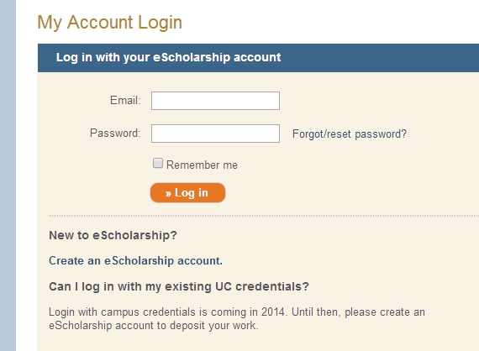

- Then click on the green “Western Journal of Emergency Medicine” link at the bottom of the screen.

- Click on the “New Submission” link on the right.
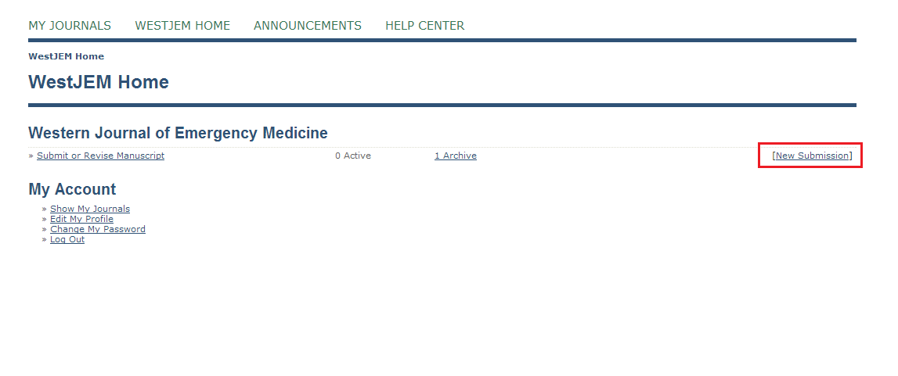
- Select a section that matches that best matches the criteria of the manuscript being submitted.

Available sections:
- Original Research
- Brief Research Report
- Review Articles
- Images in Emergency Medicine
- Letter to the Editor
- Case Reports
- Editorials
- Commentary
- Others
- Abstracts
- Treatment Protocol Assessments
- 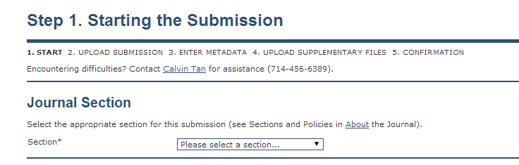

- Please make sure the manuscript you are submitting matches the guidelines on the submission checklist. You must read and agree by "checking" the boxes on left to the WestJEM conditions for peer review. Noncompliance may result in a delayed peer review process.
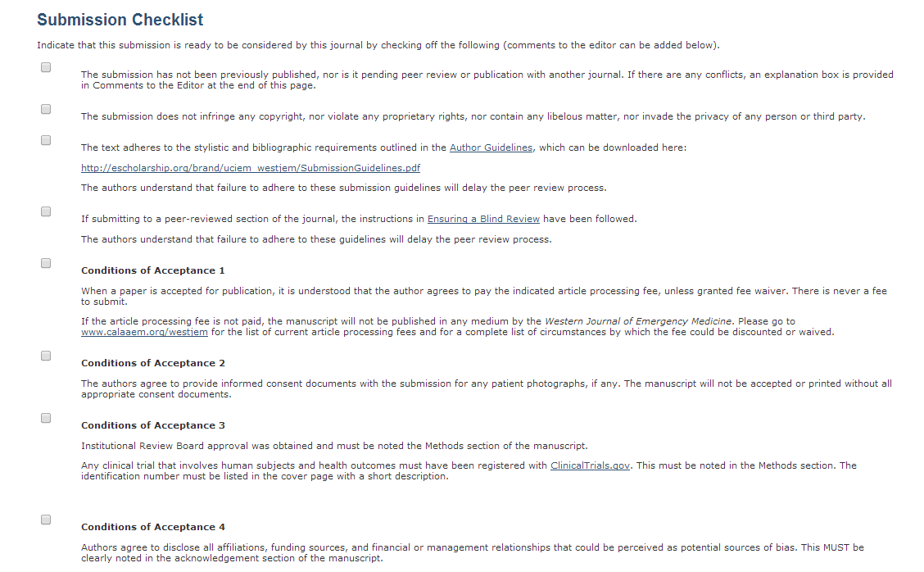

- You must agree by "checking" the box stating that you have read and understand the WestJEM Copyright Notice.

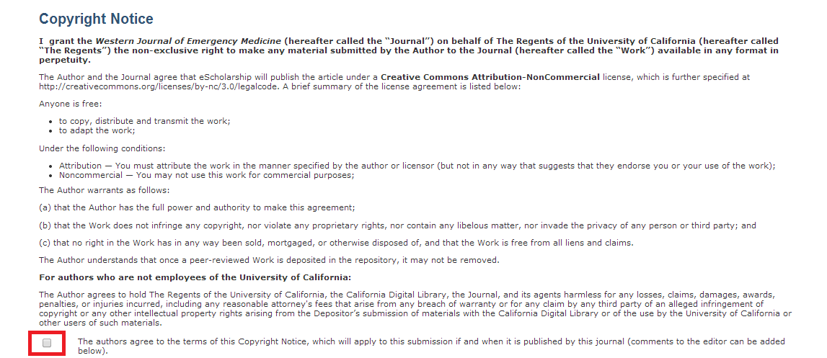
- Enter your cover letter (optional) and then click “Save and continue.”
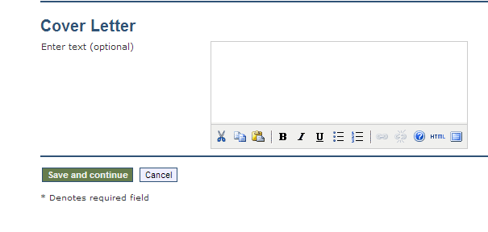

- Click “Choose File” and select the item from your computer. Verify that the file name is correct and click “upload” to submit it to our server. After the item has been successfully uploaded, click “Save and continue” for the next step.
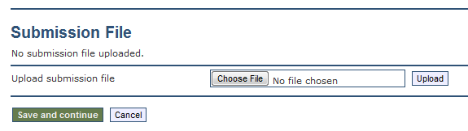

- Fill out the form with the author’s information. URLs must begin with “http://”. Please use complete sentences to complete the “Bio statement”. Additional authors can be added by clicking the “Add Author” button.
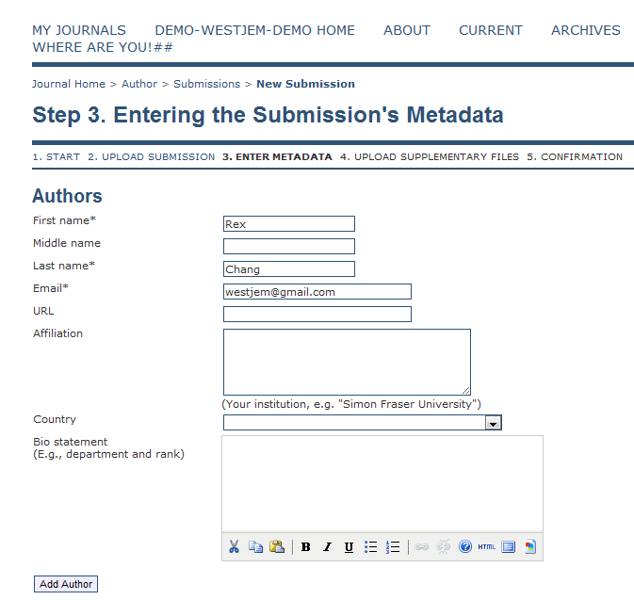

10. Enter the title of your manuscript and abstract. Please be sure to include this information in the manuscript as well. Abstracts must be structured with the objective, methods, results, and conclusion.

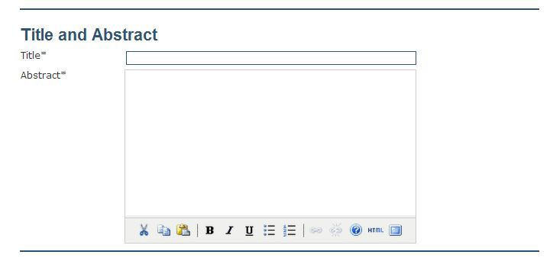

11. Enter the academic discipline, keywords, and acknowledgement in the corresponding text boxes.
Click “Save and continue” when you are ready to proceed to Step 4.
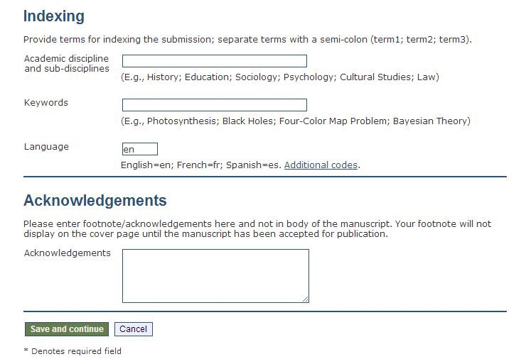

12. Upload any cover letters, figures, consent forms, appendixes, or any other files associated with the item that you are submitting here. Please be sure that ALL figures are 300 DPI. File types accepted are: JPEG, PDF, and TIFF. Please make sure to select “Upload”. Figures will not be published if these requirements are not met. Ultrasound video submissions must be properly labeled with arrows and captions. If you do not have any supplementary files, you may click “Skip and continue”.

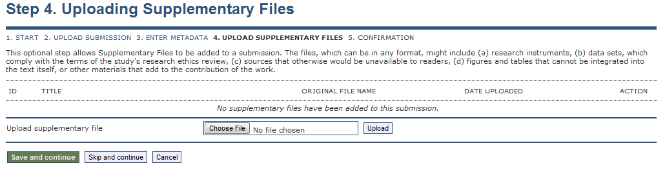

13. Confirm that all files uploaded are in the file summary. If so, click “Finish Submission” to complete your submissions.

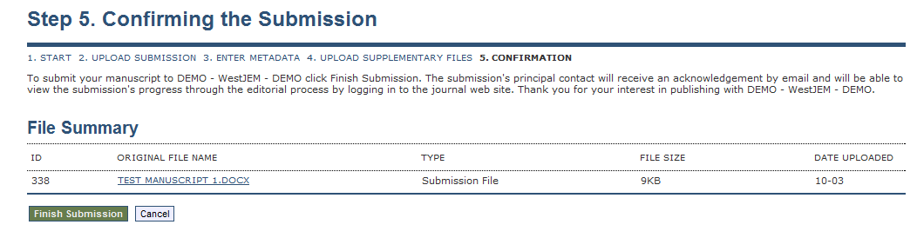
14. New and previous submissions can be viewed under "Active Submissions". The status of your submission will also be displayed under "Active Submissions"
_____________________________________________________________________________

Uploading Revisions via the website:

- Two documents are required:
  - Point by point describing what was added/removed in response to each item in the critique.
  - Revised version of the article with the “Track Changes” enabled so that all edits are clearly seen by the editors.
- Both documents (point by point and track changes) uploaded under supplementary files in the “Summary” tab

- The revised manuscript can be uploaded in the “Review” tab. You may also upload the point by point here along with the revised manuscript. Notify the editor that revisions have been uploaded.
